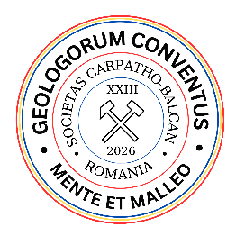 | XXIII International Congress  of the Carpathian-Balkan Geological Association  9–11 September 2026, Cluj-Napoca, Romania | Form  C

GRANT APPLICATION FORM

The deadline for grant application is June 1, 2026

Please submit this form as e‐mail attachment to cbga2026@gmail.com

First name:

Last name:

E-mail:

Institution (University, College, School):

Status:

Abstract title:

Mode of presentation

Oral: |  | Poster:

Grant request for:

Registration Fee: |  | Accommodation:

Organizing Committee signatures of Approval

Registration Fee: |  | Accommodation:

President of CBGA2026:

